Name: Astha Arpit Bhatt

Enrollment: 196140316006

**Practical – 2**

Draw ten red circles in a vertical column in the center of the applet.

**CODE:**

import java.applet.Applet;

import java.awt.*;

public class pra2 extends Applet

{

public void paint(Graphics g)

{

for(int i=0;i<10;i++)

{

g.setColor(Color.red);

g.fillOval(200, i*50, 50, 50);

}

}

}

/*

<applet code="pra2.class" width="500" height="300">

</applet>

*/

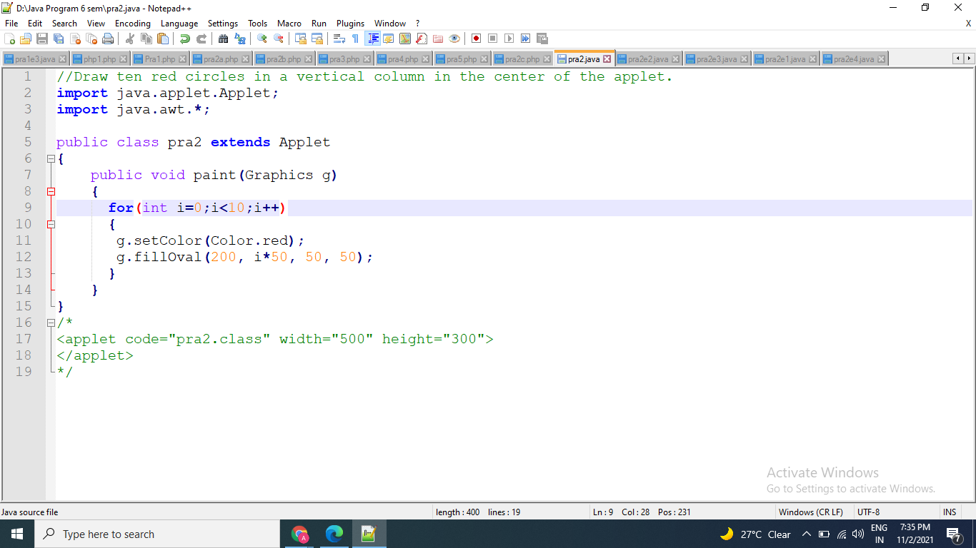

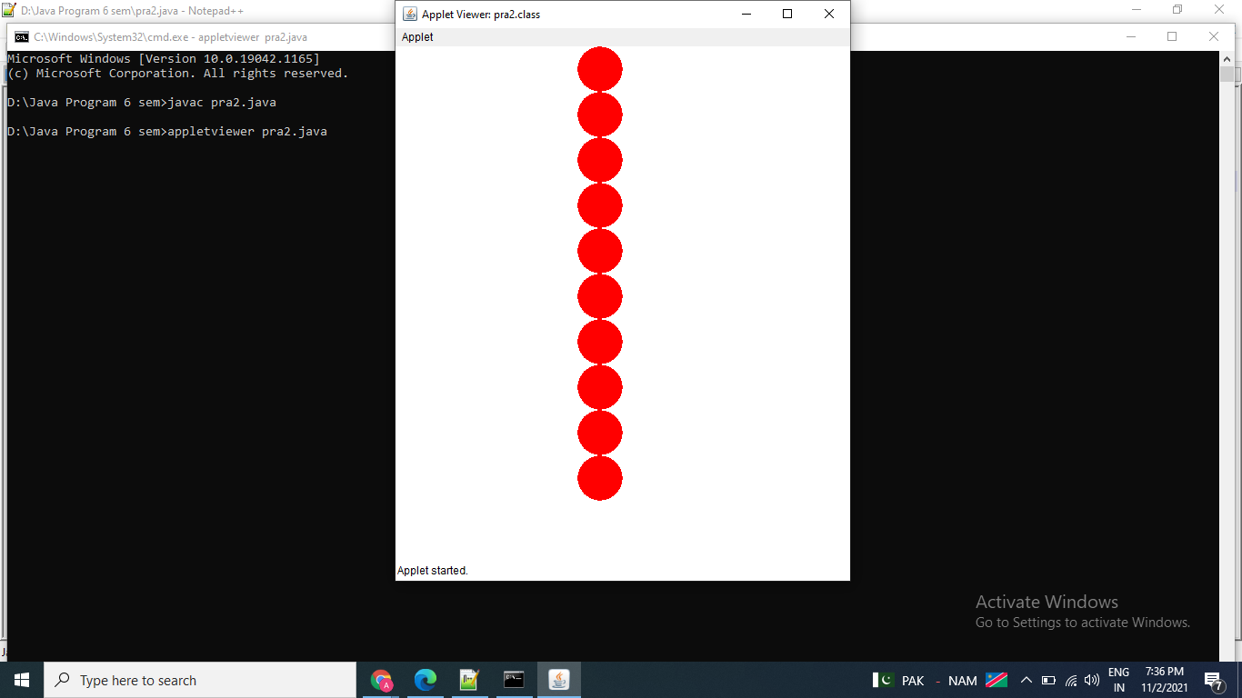

**Exercise:**

1. Draw five red circles and five blue circles alternatively in a vertical column in the centre of the applet.

import java.applet.Applet;

import java.awt.*;

public class pra2e1 extends Applet

{

public void paint(Graphics g)

{

g.fillOval(200,50,50,50);

g.setColor(Color.red);

for(int i=0;i<10;i++)

{

if(i%2==0)

{

g.fillOval(200,i*50,50,50);

g.setColor(Color.blue);

}

else

{

g.fillOval(200,i*50,50,50);

g.setColor(Color.red);

}

}

}

}

/*

<applet code="pra2e1.class" width="500" height="300">

</applet>

*/

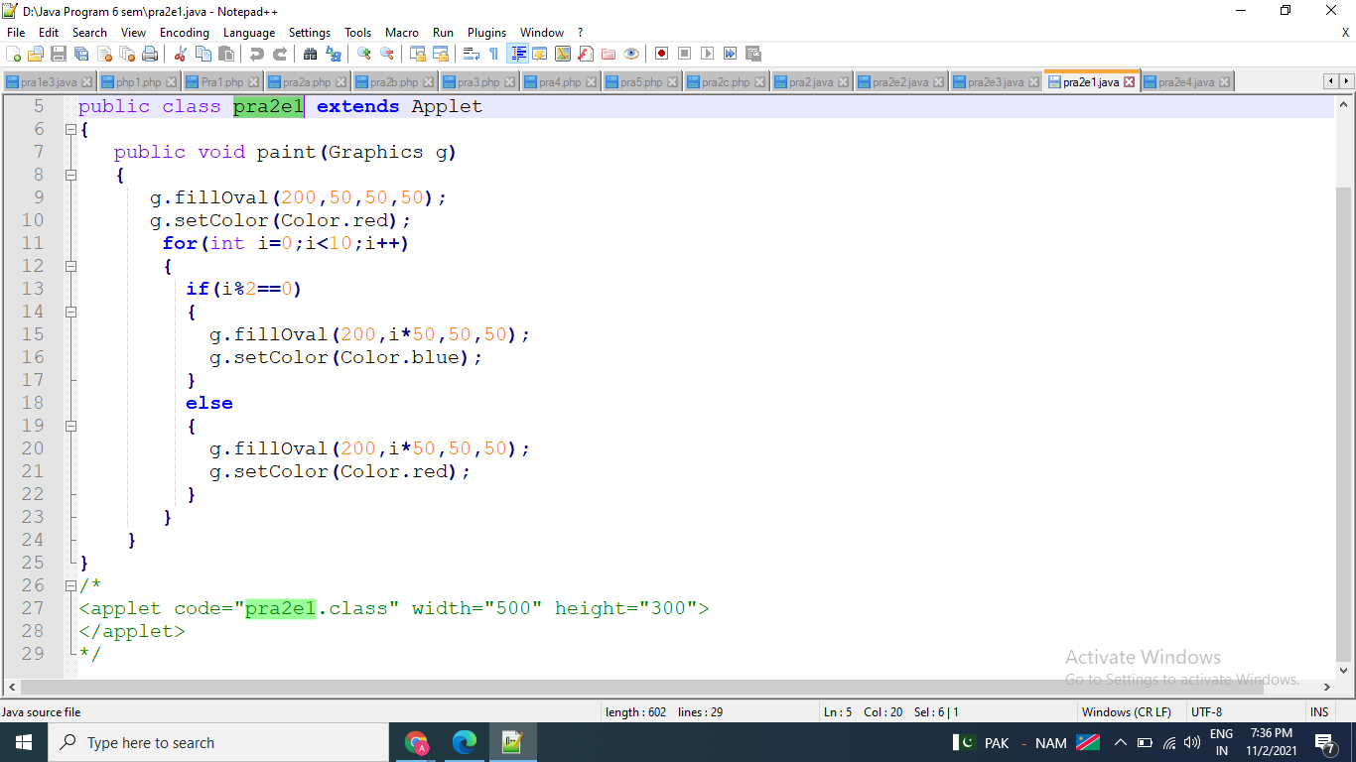

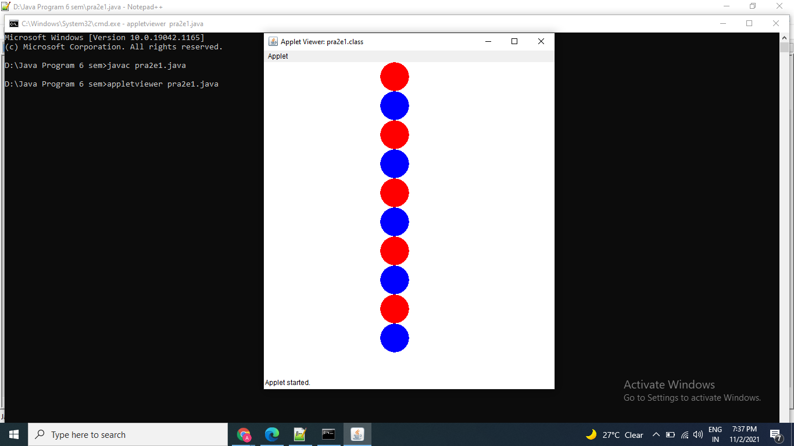

1. Draw five red circles and five blue circles alternatively horizontally in the centre of the applet.

import java.applet.Applet;

import java.awt.*;

public class pra2e2 extends Applet

{

public void paint(Graphics g)

{

g.setColor(Color.red);

g.fillOval(50,175,20,20);

g.fillOval(110,175,20,20);

g.fillOval(170,175,20,20);

g.fillOval(230,175,20,20);

g.fillOval(290,175,20,20);

g.setColor(Color.blue);

g.fillOval(80,175,20,20);

g.fillOval(140,175,20,20);

g.fillOval(200,175,20,20);

g.fillOval(260,175,20,20);

g.fillOval(320,175,20,20);

}

}

/*

<applet code="pra2e2" width="400" height="500">

</applet> */

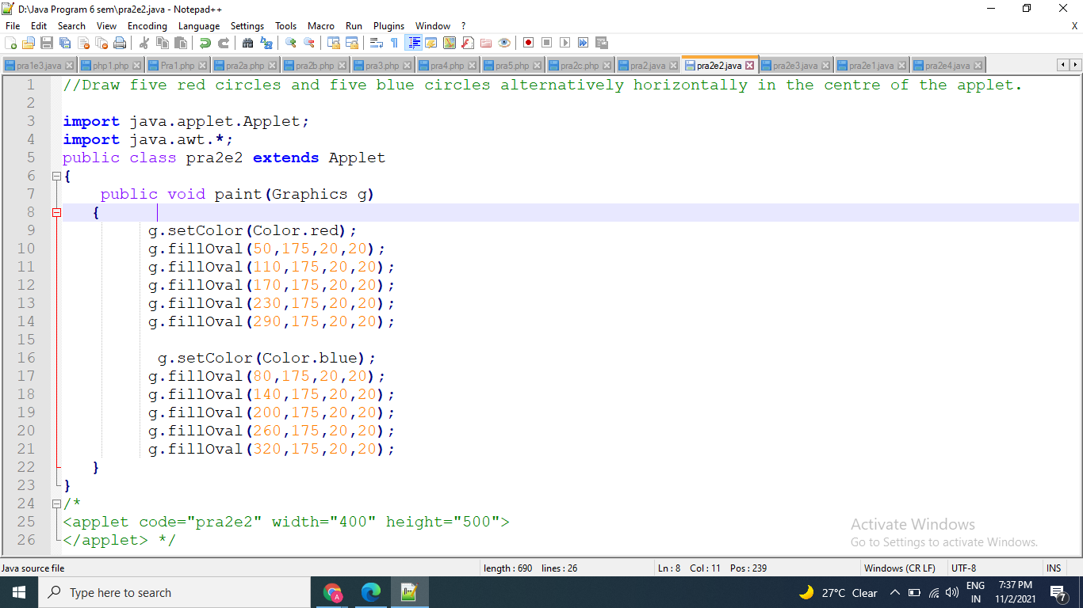

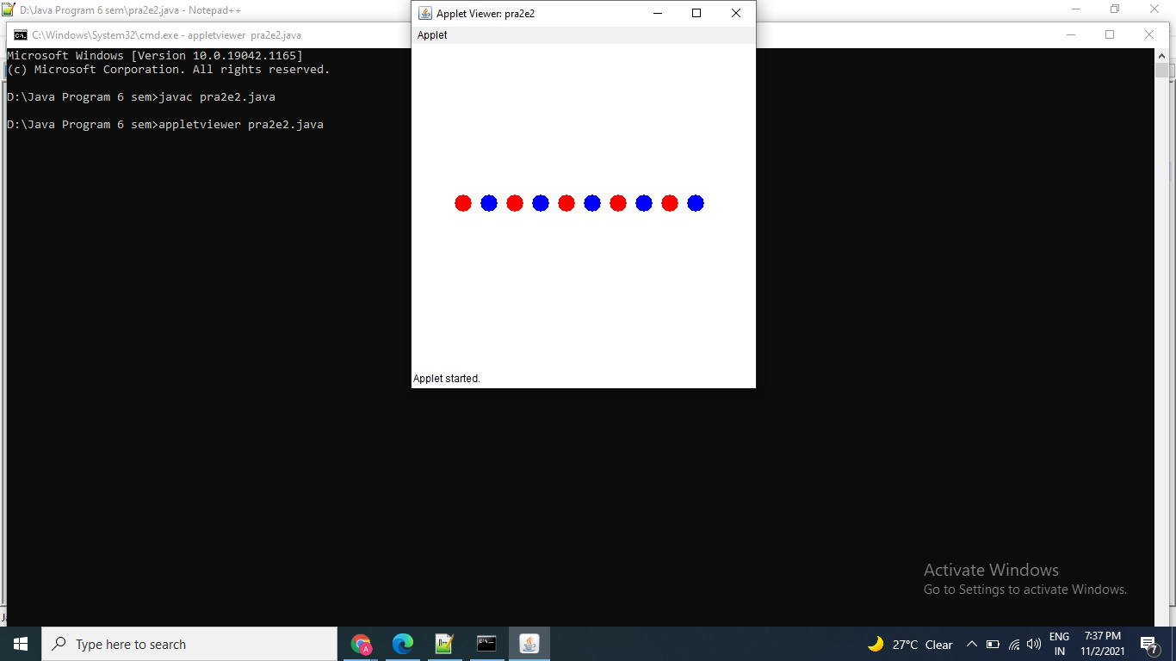

1. Draw an applet page, where left column consist of square filled in blue colour, centre column consists of oval in red colour and right column consists of rectangle filled with pink colour.

import java.applet.Applet;

import java.awt.*;

public class pra2e3 extends Applet

{

public void paint(Graphics g)

{

g.setColor(Color.blue);

g.drawRect(20,20,50,50);

g.fillRect(20,20,25,50);

g.setColor(Color.red);

g.drawOval(80,20,50,50);

g.fillOval(95,20,20,50);

g.setColor(Color.pink);

g.drawRect(140,20,50,50);

g.fillRect(165,20,25,50);

}

}

/*

<applet code="pra2e3.class" width="500" height="300">

</applet>

*/

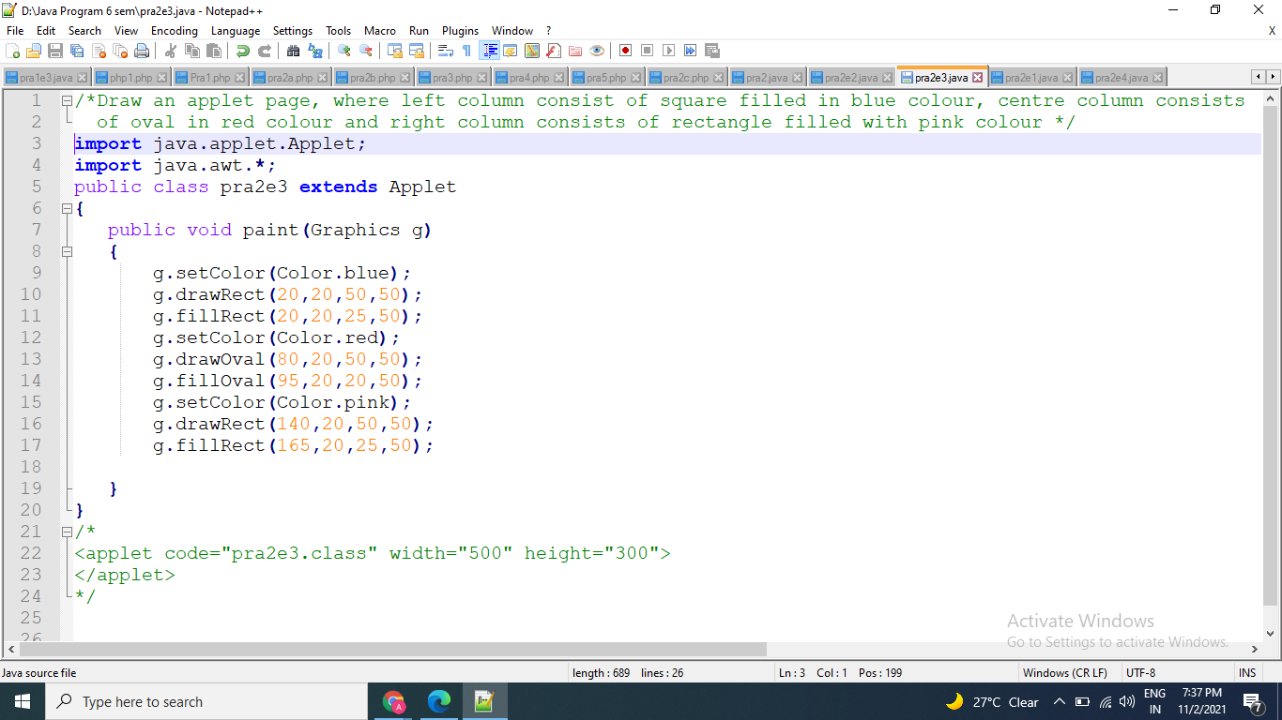

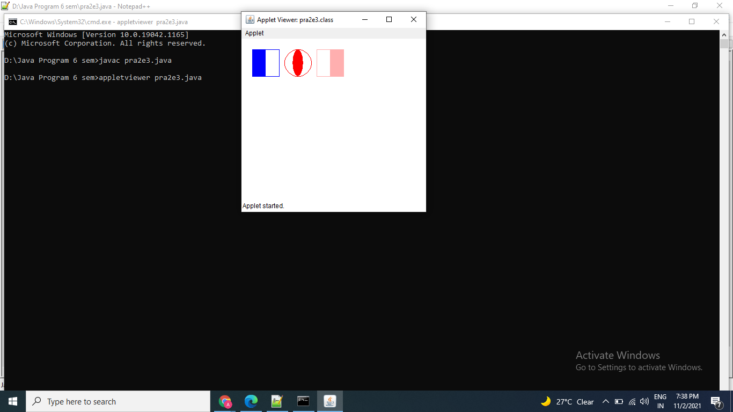

1. Draw the following applet

import java.applet.Applet;

import java.awt.*;

public class pra2e4 extends Applet

{

public void paint(Graphics g)

{

g.drawString("Applet Lifecycle",240,90);

g.setColor(Color.pink);

g.fillOval(230,110,100,100);

g.drawString("1",320,120);

g.setColor(Color.white);

g.drawString("Applet is",250,150);

g.drawString("initialized",250,170);

g.setColor(Color.red);

g.fillOval(140,190,100,100);

g.drawString("5",150,190);

g.setColor(Color.white);

g.drawString("Applet is",160,230);

g.drawString("destroyed",160,250);

g.setColor(Color.blue);

g.fillOval(320,190,100,100);

g.drawString("2",430,240);

g.setColor(Color.white);

g.drawString("Applet is",340,230);

g.drawString("started",340,250);

g.setColor(Color.orange);

g.fillOval(170,300,100,100);

g.drawString("4",160,320);

g.setColor(Color.white);

g.drawString("Applet is",190,340);

g.drawString("stopped",190,360);

g.setColor(Color.cyan);

g.fillOval(290,300,100,100);

g.drawString("3",280,390);

g.setColor(Color.white);

g.drawString("Applet is",310,340);

g.drawString("painted",310,360);

}

}

/*

<applet code="pra2e4.class" width="600" height="500">

</applet>

*/

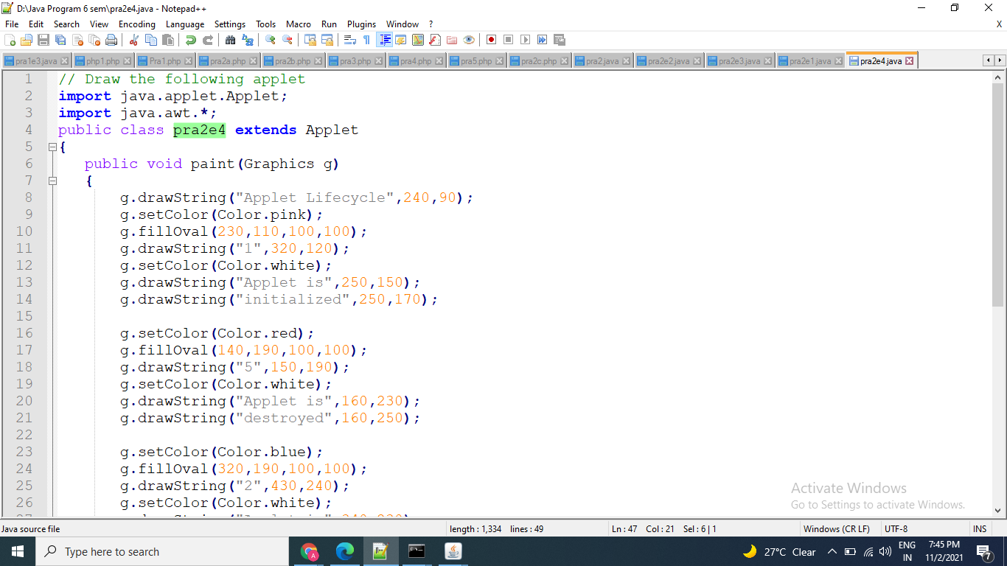

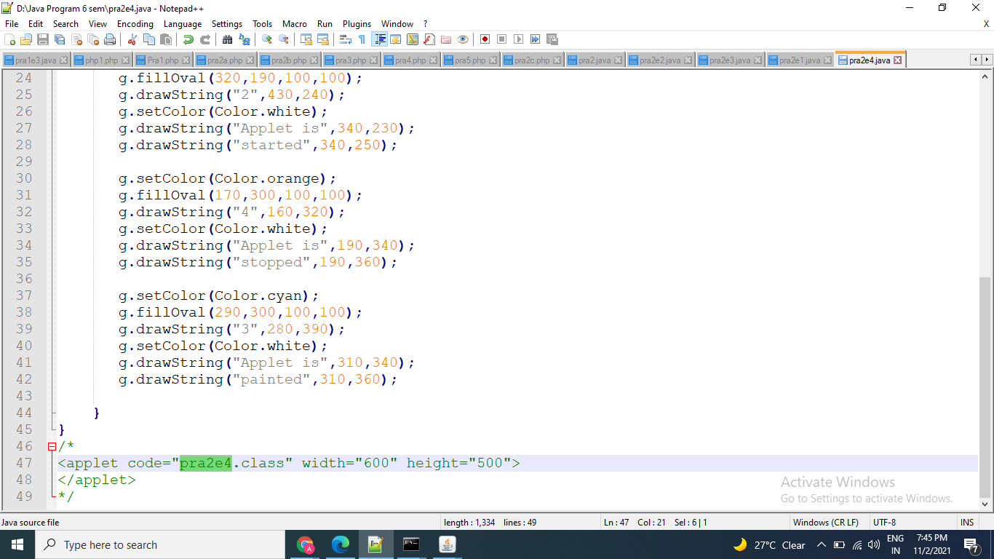

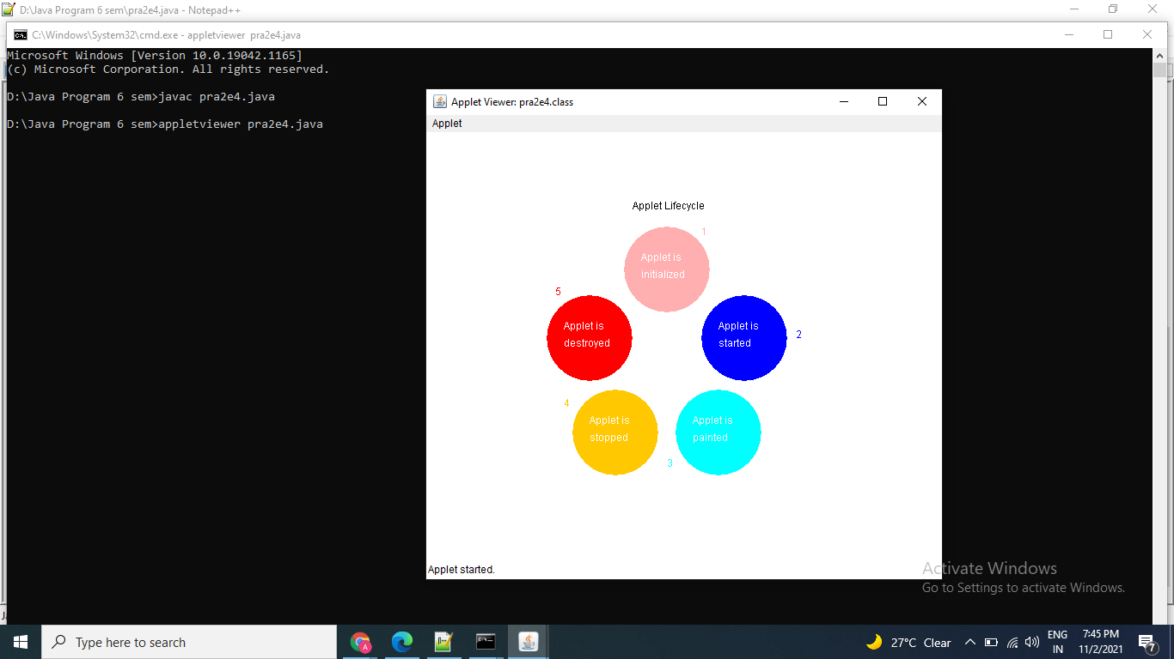

Thanks mam!!!